**Emission of CO2 and the Consumption of Electric Power**

Electric power consumption and CO2 emission are closely related, as the former is a primary cause of the latter. The more electricity we consume, the more pollution we generate, and the higher our CO2 emissions levels become. While electricity is essential to modern life, we need to consider the environmental impact of our energy consumption and explore ways to reduce it. According to a study by the Energy Information Administration (EIA), the power sector was responsible for about 38% of total CO2 emissions in the United States in 2019. This finding highlights the importance of reducing electricity consumption to curb CO2 emissions. One way to reduce electricity consumption is through the adoption of renewable energy sources such as solar, wind, and hydroelectric power. By shifting towards these sources, we can reduce our dependence on fossil fuels, which are the primary source of CO2 emissions, and decrease our carbon footprint significantly. Another approach is to use energy-efficient appliances, such as LED light bulbs, smart thermostats, and energy-efficient HVAC systems. These appliances consume less electricity and, therefore, generate fewer CO2 emissions. To understand the effect of Electric Power Consumption on CO2 emission, data has been collected from World Bank. In this context two indicators and seven countries have been selected which are as follows:

|  |  |
| --- | --- |
| **Indicators** | **Countries Selected** |
| 1. Electric power consumption (kWh per capita) 2. CO2 emissions (kt) | 1. Afghanistan 2. United Arab Emirates 3. Argentina 4. India 5. Bangladesh 6. United Kingdom 7. Germany |

The data has been obtained from 1960 to the latest time. Out of several countries and indicators, the above-mentioned have been filtered and the data has been prepared. The statistic of the data is shown below:

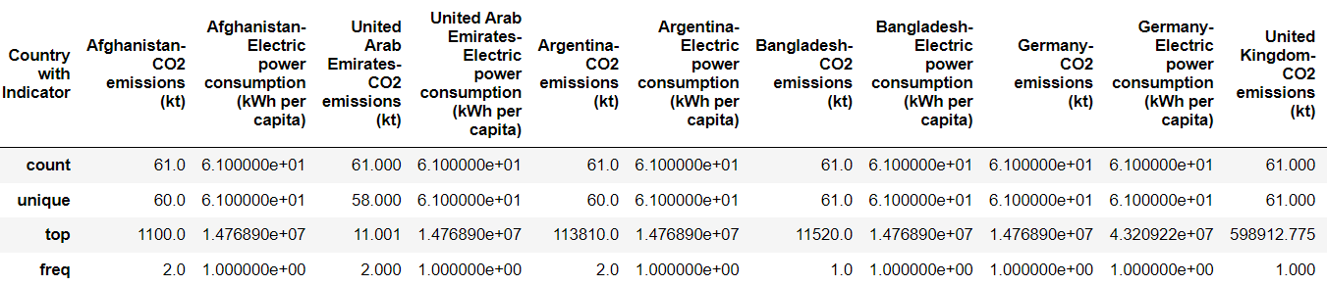

Next, the analysis has been performed by applying statistics such as mean and median to compute the energy consumption and co2 emission. The outcome is depicting the fact that the highest average consumption of electrical energy is done by Germany but the highest average co2 emission has been seen for Afghanistan. The outcome is shown below:

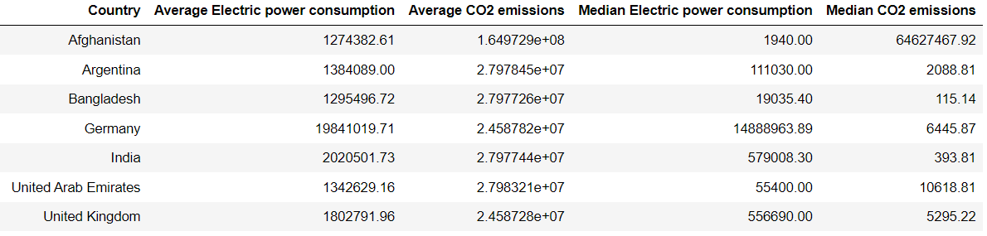

The average and median values for electrical power consumption and co2 emission have been visualised as obtained from the previous results. The visualizations are shown below:

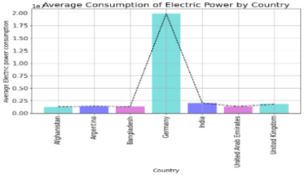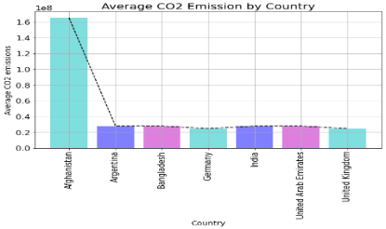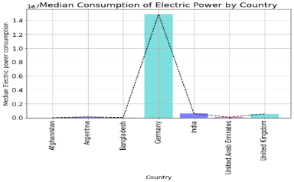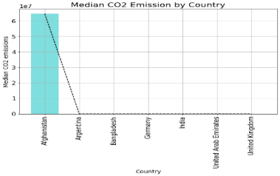

Now, the relationship between electrical power consumption and co2 emission (both for mean and median values) has been inspected through correlation. From the correlation chart, it has been observed that the average electrical power consumption and co2 emission has a negative correlation (-0.2015) and the same for the median as well (-1838). The correlation heatmap is shown below:

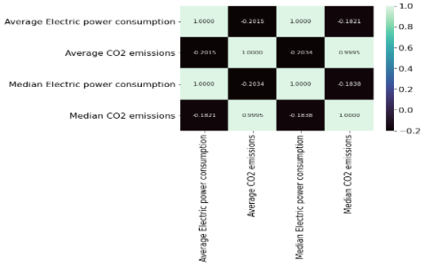

The above-presented correlation is for the overall relationship between electrical power consumption and co2 emission for all countries. Finally, the correlation has been performed regarding the indicators foal l seven selected countries and the heatmap is shown below:

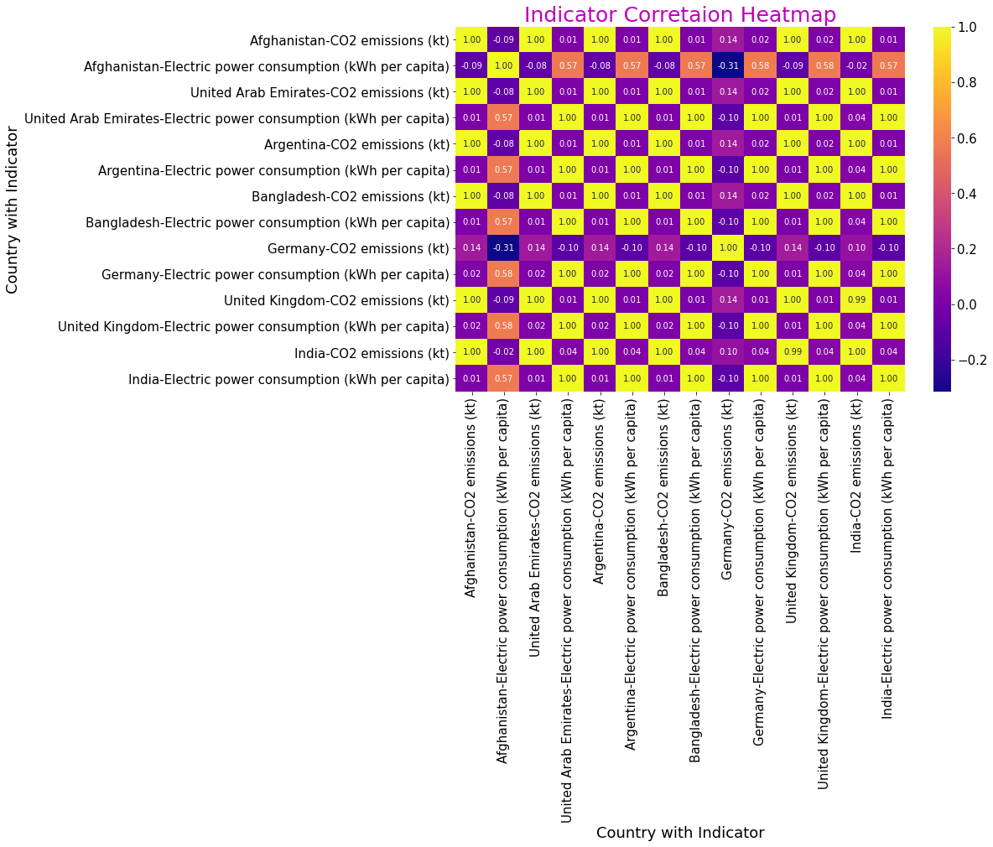

So, in the overall analysis, the electrical power consumption and co2 emission for seven countries have been examined and presented. Finally, the relationship between electrical power consumption and co2 emission for all countries regarding the selected indicators has been done and depicted using a correlation heatmap.